Github/Github Desktop Overview
Common Git and Github Terms and Analogies:
📁A Repository (Repo)
A repository is the complete storage location for your project. It contains your files along with all version history managed by Git. Think of it as a project folder combined with a time machine that remembers every change ever made.

📥Clone
Cloning creates a full local copy of a GitHub repository on your computer, including all history and branches. It allows you to work offline and make changes independently before sending them back to GitHub.

🌿MAIN (branch)
main is the default primary branch of a Git repository. It represents the version of the project that is considered stable, deployable, or production-ready. When you create a new repository on GitHub, it automatically creates a branch named main to serve as this central reference point.

🌿Branch
A branch is a separate line of development that allows you to work on new features without affecting the main code. Branches let you experiment safely and merge your work back into the main project when ready.

🧭Origin
Origin is the default name that Git gives to the remote repository you cloned from. It is simply a nickname or label that points to the GitHub (or other server) version of your repository. It does not mean anything special by itself — it’s just a convenient shortcut so you don’t have to type the full URL every time.

📸 Commit
A commit is a saved snapshot of your project at a specific moment. Each commit has a message describing what was changed from the previous version of the code. You can always return to or compare commits, making them essential for tracking progress and undoing mistakes.

🔄Pull
Pulling updates your local copy of a repository by downloading the latest changes from GitHub and merging them into your current branch. It keeps your work synced with the main project.

⬆️ Push
Pushing uploads your commits from your local machine to GitHub. Your changes don’t appear online or become shared with others until you push.

📨 Pull Request (PR)
A pull request is a formal request to merge one branch’s changes into another. It is where code is reviewed, discussed, and approved before being added to the main project. The reason it is called a pull request and not a push request is because you don’t own the rights to the remote repository you are trying to push to, the owner pulls those changes.

🍴Fork
A fork is your own copy of someone else’s repository on your GitHub account. It lets you freely modify the project and later propose your changes back to the original author.

🔀Merge
Merging combines the changes from one branch into another, integrating multiple lines of development into a single updated version of the project.

🧾README
The README is the main documentation file of a repository. It explains what the project is, how to use it, and any important setup instructions. It serves as the project’s introduction and user guide.

Common GitHub Workflows:

Creating/Cloning a Repository
- >> Current Repository
- >> Add
- >> Clone Repository or Add Repository

Committing to a Repository:
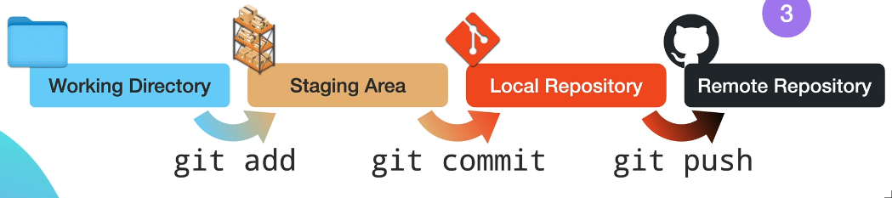

Going back to a Previous Version:
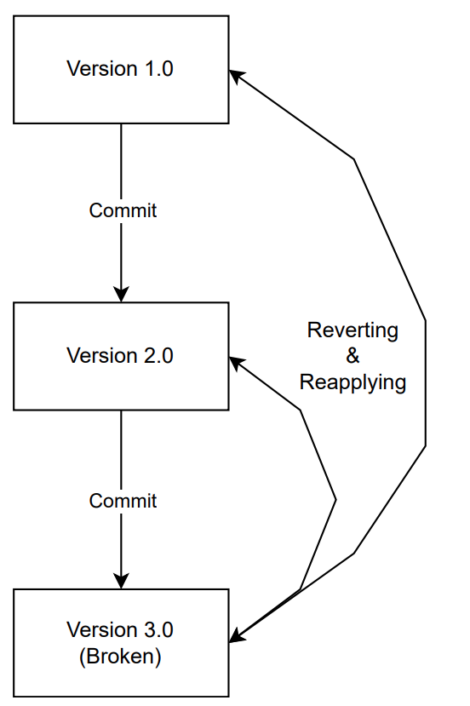

Branching and Creating a Pull Request:
- Create a branch
- Make changes to code/files
- Commit and push changes
- Compare changes & create Pull Request
- Submit Pull Request for review from other team members

Resolving a Merge Conflict:
- Open the conflicted file
- Choose which version to keep
- Commit the resolution

